**Create a simple LAN setup with two Linux machines connected via a switch.**

**STEPS I HAVE FOLLOWED:**

* Cloned my Ubuntu machine in VirtualBox to create two VMs.
* Configured network adapters in VirtualBox
* Added both VMs to GNS3 and connected them to a switch.
* Checked network interfaces inside the VMs.
* Assigned IP addresses manually to the enp0s3 interface.
* Attempted to ping between the VMs to test connectivity.

**Adding both the Linux machines to GNS3:**

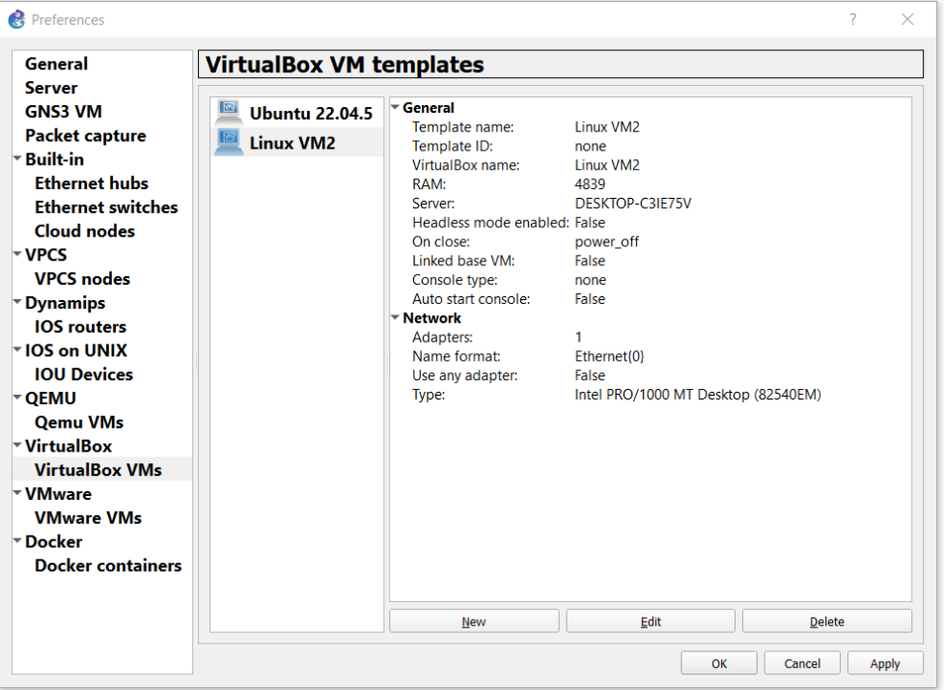

**Setting Up:**

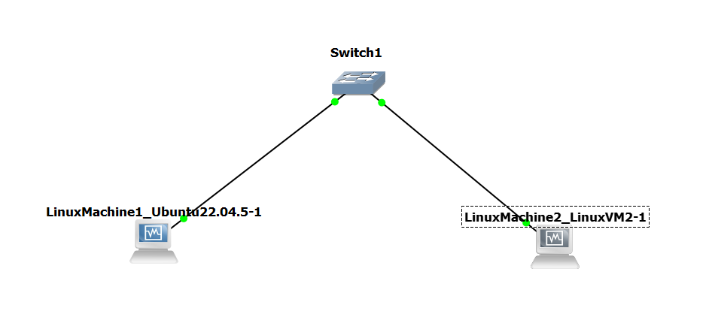

**Pinging Machine1 🡪 Machine2:**



**Pinging Machine2 🡪 Machine1:**



**I can ping the machines from each other. Hence, the LAN setup is complete.**